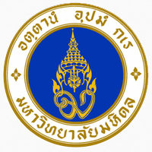

Application Form
Mahasawat Agro-Community Tourism
19th December 2019
Name-Family name ................................................................................................................
Office .....................................................................................................................................
Address ..................................................................................................................................
Telephone  Home .................................................... Office ............................................
❑ Mobile Telephone ....................................................Fax ................................................
E-mail:.......................................................................................................................................
Fee: 1,000 baht/person
Payment methods:
Payment by BANK TRANSFER.
Account Name: RESEARCH INSTITUTE FOR LANGUAGES AND CULTURES OF ASIA
Bank Name: THE SIAM COMMERCIAL BANK PCL.
Bank Branch: MAHIDOL UNIVERSITY SUB BRANCH
Bank Address: 999 MAHIDOL UNIVERSITY
PHUTTAMONTON SAI 4 RD. SALAYA, PHUTTMONTON, NAKHONPATHOM, THAILAND
(ZIP CODE 73170)
Account Number 333-221774-5
SWIFT CODE SICOTHBK

Submission of Registration Form & Payment:
The registration form, and a proof of payment should be submitted via mail e-mail to:
Research Institute for Languages and Cultures of Asia,
Mahidol University, Salaya Sub-District, Phuttha Monthon District,
Nakhon Pathom 73170 THAILAND
E-mail: lcprilcaconf2019@gmail.com

